**Date**: 29/Jun/2020

**Author**: Nikhil Madduri (nikhil.madduri@gmail.com)

**../5_replacing Sfunction with own rk4/**

**3_kin_dyn_working_v1/**

* Replaced vtol_dynamics that used S-function with own vtol_dynamics that uses rk4.m and sixDOF.m to integrate the 6-DOF equations.
* Since it was the first trial passing of vtol structure is a bit crude which I have figured out in the next cases.
* **Successful.**

**3_kin_dyn_rk4_refined_v2/**

* Refined the vtol_dynamics.m, rk4.m and sixDOF.m by removing unnecessary lines.
* But passing of vtol variable is still crude – defined all the numbers within sixDOF.m file rather that reading vtol from other file as a structure.
* **Successful.**

**3_kin_dyn_v3/**

* I’m now able to read vtol as a structure from vtol_parameters.m without having to hard code the values within sixDOF.m. This was made possible by replacing the vtol_dynamics matlab function block with interpreted matlab function block.
* Secondly even the initialization block has been made more succinct as follows –

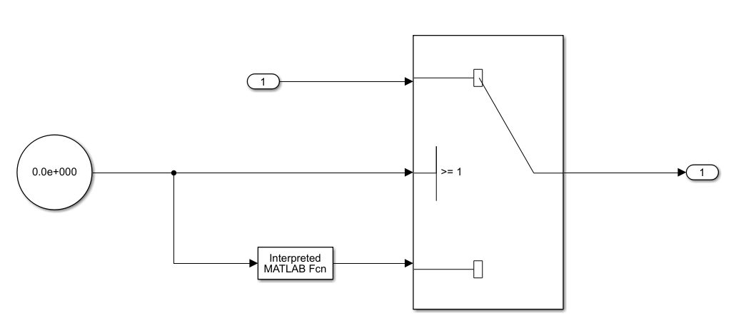

* **Successful.**

**3_kin_dyn/**

* Testing folder – unsuccessful.
* When I tried to use the logic developed in “**3_kin_dyn_v3/**” by replacing the vtol_dynamics in vtolsim_trim .slx in the folder \e_version\5_ldm\testcases\3_replacing_S_function_with_own_rk4, trimming is not successful. Program throws errors.
* Hence I was trying to figure out what was causing the issue in the model below (“**3_kin_dyn_v3/**” )—

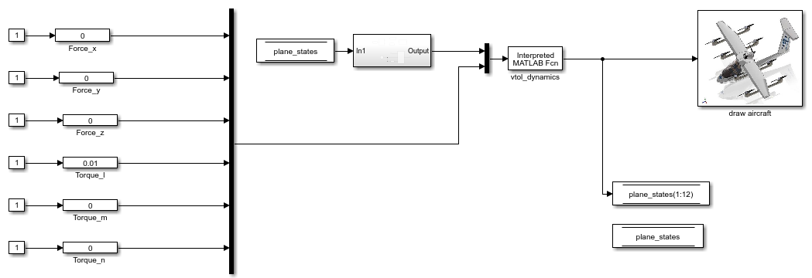

I thought may be the states are being stored in plane_states memory block whereas in the old vtol_dynamics model I used to loop like this for trimming —

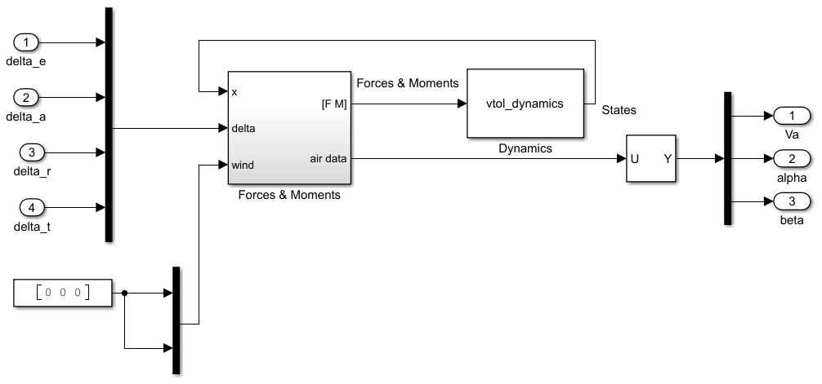

* So in “**3_kin_dyn/**” I tried such looping but errors are thrown.
* **Unsuccessful.**